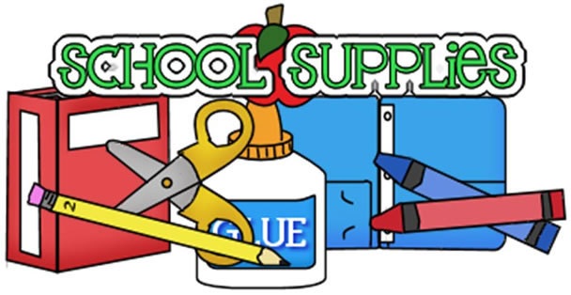**3rd Grade Supply List**

**2024-2025**

*Your child will need the following supplies at school.* ***Some supplies might need to be replenished throughout the year.***

* 2 pack of pencils (12 count)
* 2 block erasers
* 1 pack of Wide-ruled loose leaf notebook paper
* 1 pencil pouch (no boxes)
* 1 pack of 3 x 5 sticky notes
* 1 ½ inch 3 ring binder with pockets
* 1 pack of notebook dividers
* 1 pair of over ear headphones for personal use (no earbuds)
* **Students will be issued devices to use in the classroom and at home. Since there will be personalized learning in the classroom, the headphones will limit distractions in the learning environment.**
* ***Supplies need to be available at home for homework.***
* ***Pencil sharpener***
* ***Glue***
* ***Crayons***
* ***Pencils***
* ***Scissors***

***Wish List***

***Antibacterial Wipes***  ***Kleenex***